Experiment Details

|  |  |
| --- | --- |
| Department Name | Department of Civil Engineering |
| Class | SY |
| Semester | III |
| Subject Name | Engineering Hydraulics |
| Experiment No. | 1 |
| Experiment Name | To determine the metacentric height of ship model |

Version History

|  |  |  |  |  |
| --- | --- | --- | --- | --- |
| Sr. No. | Version Number | Created By | Approved By | Date |
| 1 | v1.0 | Haripriya Desai | Prof. A. K. Khebudkar & Prof. M. M. Mujumdar | 08/02/2021 |
|  |  |  |  |  |

AIM:

To determine experimentally the metacentric height of a floating body, i.e., a ship model.

THEORY:

Metacenter:

**Buoyancy**

When a body is completely submerged in a fluid, or it is floating or partially submerged, the resultant fluid force acting on the body is called the buoyant force. It is also known as the net upward vertical force acting on the body. A net upward vertical force results because pressure increases with depth and the pressure forces acting from below are larger than the pressure forces acting above.  
The Center of buoyancy is the center of gravity of the displaced water. It lies at the geometric center of volume of the displaced water.

**Metacentre**

For the investigation of stability of floating body, it is necessary to determine the position of its metacentre with respect to its centre of gravity. Consider a floating ship model, the weight of the ship acts through its centre of gravity and is balanced by an equal and opposite buoyant force acting upwards through the centre of buoyancy i.e. the centre of gravity of liquid displaced by the floating body.

A small angular displacement shifts the centre of buoyancy and the intersection of the line of action of the buoyant force passing through the new centre of buoyancy and the extended line would give the metacentre.

The distance between centre of gravity (G) and metacentre (M) is known as Metacentric height (GM). There are three conditions of equilibrium of a floating body.  
Stable Equilibrium - Metacentre lies above the centre of gravity  
Unstable Equilibrium- Metacentre lies below the centre of gravity  
Neutral Equilibrium - Metacentre coincides with centre of gravity

The Metacentric height (GM) is given by GM = (w * x) / (W * tan θ)  
where,  
W = weight of the floating body + movable weight  
w = movable weight  
x = distance through which the movable load is shifted  
θ = Angle of Heel

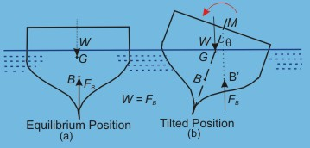

PRE TEST:

Q.1 What is the principal cause of action of buoyant force on a body submerged partially or fully in fluid?  
a) Displacement of fluid due to submerged body (Answer)  
b) Development of force due to dynamic action  
c) Internal shear forces mitigating external forces  
d) None of the mentioned

Q.2 Proper explanation for metacenter is:  
a) Point at which line of action of force meets the normal axis of body when it is given angular displacement  
b) Intersection of line passing through new center of buoyancy and center of gravity.  
c) point about which body starts oscillating when it is given small angular displacement  
d) All of the mentioned (Answer)

Q.3 The metacentric height is affected by the change in density.  
a) True (Answer)  
b) False

Q.4 For a completely immersed body, the metacentric height is always zero.  
a) True  
b) False (Answer)

Q.5 The principle of floatation of bodies is based on the premise of  
a) Metacenter (Answer)  
b) Newtons first law  
c) Newtons law of viscosity  
d) None of the mentioned

PROCEDURE:

1. Fill the water tank to about 2/3 levels.
2. Place the floating body in the tank.
3. Apply momentum to the floating body by moving one of the adjustable weights (w) through a known distance (x)
4. Note down the angle of heel (θ) corresponding to this shift of weight with the help of protractor and pointer.
5. Take about 4-5 such readings on right and left side of the ship model by changing the position of the adjustable weight and find out centre of gravity in each case.

Observation Table

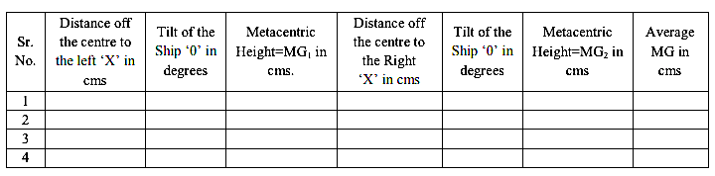

POST TEST:

Write minimum five MCQ’s along with answer. (Based on given experiment)

REFERENCES:

Fluid Mechanics – Streeter-McGraw-Hill International Book Co., Auckland